Kod Projek :
BORANG LRGS-P1(R)-PROGRAM

PROGRESS REPORT
LONG TERM RESEARCH GRANT SCHEME (LRGS)

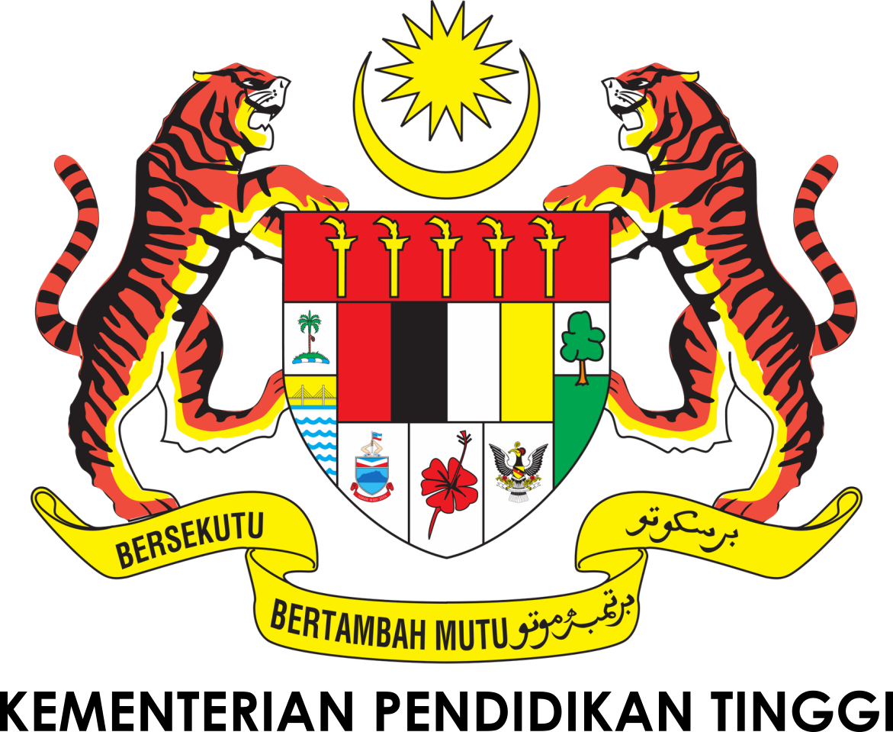
Laporan Prestasi Skim Geran Penyelidikan Jangka Panjang
TITLE OF RESEARCH PROGRAM (Tajuk Program Penyelidikan)

A |  | PHASE:  Fasa :  LEADING IPT :  IPT Peneraju :  Niche :  Nic :  Title of Research Program  (Tajuk Program Penyelidikan):  START DATE:  Tarikh Mula :  END DATE:  Tarikh Tamat :  Program Leader :  (Ketua Program)
 | Title of Research Project  (Tajuk Projek) |  | Membership  (Keahlian) | Field  (Bidang) | Institution  (Institusi)
 |  |  | Leader (Ketua):
 |  |  | Member (Ahli):
 |  |  | i.
 |  |  | ii.
 |  |  | iii.
 |  |  | iv.
 |  |  | v.
 | Title of Research Project  (Tajuk Projek) |  | Leader (Ketua):
 |  |  | Member (Ahli):
 |  |  | i.
 |  |  | ii.
 |  |  | iii.
 |  |  | iv.
 |  |  | v.
 | Title of Research Project  (Tajuk Projek) |  | Leader (Ketua):
 |  |  | Member (Ahli):
 |  |  | i.
 |  |  | ii.
 |  |  | iii.
 |  |  | iv.
 |  |  | v.
 | Title of Research Project  (Tajuk Projek) |  | Leader (Ketua):
 |  |  | Member (Ahli):
 |  |  | i.
 |  |  | ii.
 |  |  | iii.
 |  |  | iv.
 |  |  | v.
 | Title of Research Project  (Tajuk Projek) |  | Leader (Ketua):
 |  |  | Member (Ahli):
 |  |  | i.
 |  |  | ii.
 |  |  | iii.
PROGRAM ACHIEVEMENT (Prestasi Program)
B
  ACHIEVEMENT PERCENTAGE
  Program progress according to milestones achieved up to this period |  | 0 - 25% |  |  | 26 - 50% |  | 51 - 75% |  | 76 - 100%
  Percentage
  (please state %)
  RESEARCH OUTPUT
  Number of articles/ manuscripts/ books  (Please attach the First & Acknowledgement Page of Publication) |  | Indexed Journal |  |  |  |  | Non-Indexed Journal
  Conference Proceeding (Please attach the First & Acknowledgement Page of Publication) |  | International |  |  |  |  | National
  Intellectual Property
  (Including Patent, Copyright, Industrial Design,layout Design of Integrated Circuit & Trademarks)
  TALENT
  Talent | Number |  |  |  |  |  |  | Others  (please specify)
  Talent | On-going |  |  | Graduated
  Citizen | Malaysian |  | Non Malaysian | Malaysian |  | Non Malaysian
  PhD Student
  Master Student
  Undergraduate Student
  Total
EXPENDITURE (Perbelanjaan)
C | Budget Approved (Peruntukan diluluskan) : RM  Amount Spent (Jumlah Perbelanjaan) : RM  Balance (Baki) : RM  Percentage of Amount Spent : %  (Peratusan Belanja)
SUMMARY OF RESEARCH FINDINGS (Ringkasan Penemuan Projek Penyelidikan)
D
PROBLEMS / CONSTRAINTS IF ANY (Masalah/ Kekangan sekiranya ada)
E
Date : Program Leader’s Signature & Stamp:
Tarikh Tandatangan & Cop Ketua Program
COMMENTS, IF ANY/ ENDORSEMENT BY RESEARCH MANAGEMENT CENTER (RMC)
(Komen, sekiranya ada/ Pengesahan oleh Pusat Pengurusan Penyelidikan)
F | ....................................................................................................................................................................  ....................................................................................................................................................................  ...................................................................................................................................................................  Name: Signature:  Nama: Tandatangan:  Date:  Tarikh:

